This project is pretty big and can be difficult to navigate from the start. I made a small (incomplete) flowchart to help the readability of this project. The main class (and method) are found in the flightPlan.java file. I hope this helps!

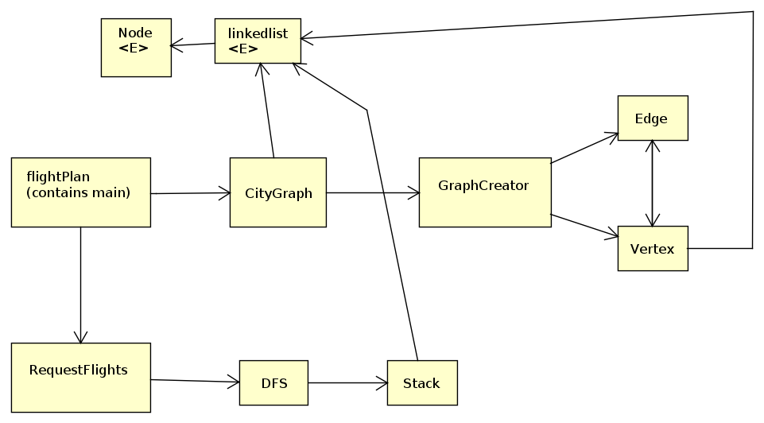NOTE: The infiles I uploaded contain sample data taken from the assignment document. Feel free to add/remove/change data as necessary to check the correctness of my code